EVENT MANAGEMENT

1. INDRODUCTION

Events management is the process of creating and maintaining an event. This process spans from the very beginning of planning all the way to post- event strategizing. At the starts, an event manager makes planning decisions, such as the time, location and theme of their event.

* 1. OVERVIEW

Events managements is the process of analyzing, planning, marketing, production and evaluating an event. It is a different way of promoting a product, service or idea. if an event is managed efficiently and effectively, it can be used as a very powerful promotional tool to launch or market a product or service.

* 1. PURPOSE

Event management is the process of creating and maintaining an event. This process spans from the very beginning of planning all the way to post-event strategizing.at the starts, an event manager makes planning decisions, such as the time, location, and theme of their event.

1. PROBLEM DEFINITION & DESIGN THINKING
   1. EMPATHY MAP

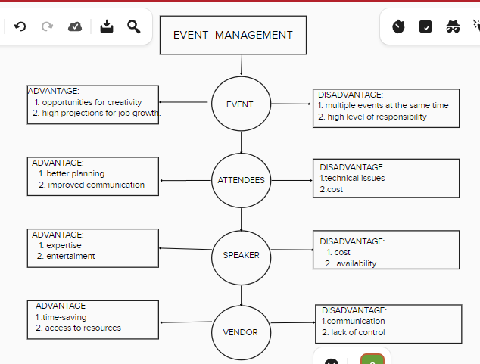

* 1. IDEATION & BRAINSTROMING MAP SCREENSHOT

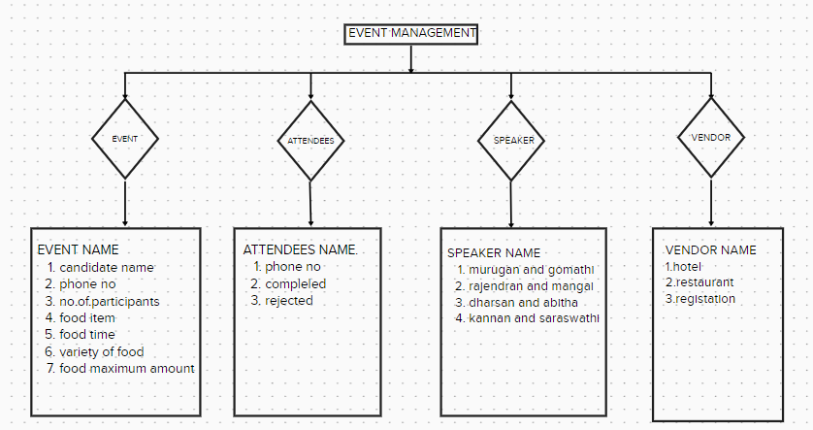

1. RESULT
   1. DATA MODEL:

|  |  |  |
| --- | --- | --- |
|  |  |  |
|  |  |  |
|  | |  |  |  | | --- | --- | --- | |  |  |  | |  |  |  | |  |  |  | |  |  |  | |  |  |  | |  |  |  | |  |  |  | |  |
|  |  |  |
|  |  |  |

|  |  |  |
| --- | --- | --- |
|  |  |  |
|  |  |  |